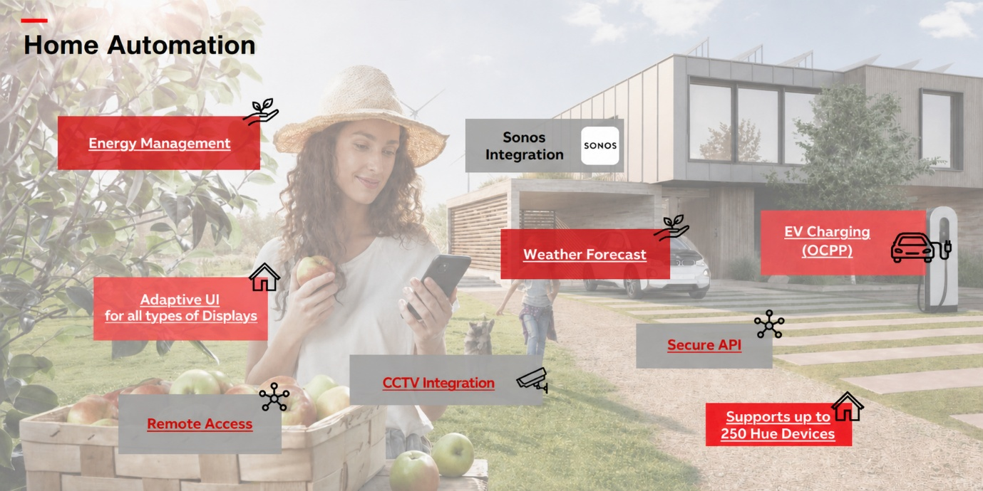
Smart Home Automation
Upgrade your villa into a fully connected smart home designed for comfort, convenience, and control.
Complete Home Control
Easily manage all lights, fans, and air-conditioning systems from your mobile phone or through voice commands. Bedrooms can also include stylish keypads for quick access, especially when using advanced VRF air-conditioning systems.
Elegant In-Room Touch Panels
Each room comes with sleek touch-based control panels, allowing you to control lighting, temperature, and more with just a tap.
Advanced Lighting with DALI System
Experience premium lighting with smooth dimming and customizable scenes. The system supports up to 64/128* lighting circuits, giving you flexibility to design the perfect ambiance for every space. It also supports Colour Tuning for implementing Human Centric Lighting.
CCTV Security System
Keep your home secure with 4/8* high-definition CCTV cameras installed across key areas of your villa.
Motorized Curtains
Automate your curtains across all rooms (up to 4/9 units) and control them effortlessly via app, voice, or touch panel.
Dedicated Climate Control
Each bedroom includes thermostat keypads for precise temperature control, always ensuring maximum comfort (only with VRF).
Energy Monitoring Dashboard
Track and optimize your home’s energy usage through a centralized dashboard, helping you save energy and reduce costs.
Smart Integrations
Enhance your experience by integrating with popular systems like Sono’s speakers, Philips Hue lighting, and EV chargers based on OCPP standards.

Make your villa smarter, safer, and more efficient — all tailored to your lifestyle.
*Based on the package chosen – Gold or Platinum, Circuits, Keypads changes accordingly but the core feature remains the same viz. Remote access, Voice Control, OCPP Integration, CCTV & Sonos Integration.

